Color Theory Review
DMAD - Mehalko

Complementary Colors
Directions: A color’s complement is the color directly across from it on the color wheel. Use the color wheel below to identify pairs of complements
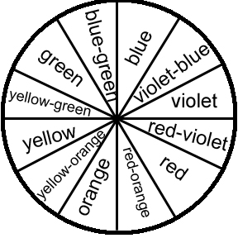

- Red and ______________________ are complementary colors.
- Yellow-orange and __________________________ are complementary colors.
- Blue and _________________________ are complementary colors.
- Red-violet and ________________________ are complementary colors.
- Blue-green and __________________________ are complementary colors.

Color Value: Tints and Shades
Directions: Circle whether each color in bold is a tint or a shade. Then, in the blank, write what hue the bold color stems from.
Example: Ochre is a (tint or shade) of ___orange____
- Pink is a (tint or shade) of ___________________
- Navy is a (tint or shade) of __________________
- Lavender is a (tint or shade) of ___________________
- Burgundy is a (tint or shade) of ___________________
- Forest is a (tint or shade) of ___________________
Color Categories
Directions: Draw a circle around the primary colors. Draw a rectangle around the secondary colors. Draw a triangle around the tertiary colors.
- orange 18. blue
- blue-green 19. red-orange
- yellow-green 20. green
- yellow 21. blue-violet
- violet 22. yellow-orange
- red-violet
- red
Color Properties
23. ____________________ is the lightness or darkness of a color
24. ____________________ is the brightness or dullness of a color
25. ____________________ is the name of the color

